TITLE
Name, Surename¹, Name, Surename² and Name, Surename²,*
¹Affiliation 1; ORCID
²Affiliation 2; ORCID
*Correspondence: e-mail@e-mail.com

Type of the Paper (original scientific article, review, professional paper, etc.)

Abstract
The abstract should summarize the contents of the paper in short terms, i.e. 150-250 words. We recommend a structured abstracts highlighting the rationale of the study (backgorund) briefly describe the main methods applied; summarize the main results, and main conslusions.
Keywords: keyword 1; keyword 2; keyword 3 (up to five keywords)

Introduction
The introduction should briefly place the study in a broad context, stating the current state of the research field but also highliting the importance of the conducted research. Review the key publications cited carefully. We recommend to start with broad context and highlight importance of the study, then narrow with the objectives (hypotheses) of the particular study. All the references mentioned in the text should be cited APA 6 citation style (i.e.) (Mujčinović et al., 2021; Puigdueta et al., 2021; White, 2011). We strongly encourage use of bibliometric softwares.
Materials and Methods
This sections should be writen with enough details to allow replication of such experiment or study design. New methods (protocols) should be described in detail, enabling the replication of the experiment. Already established methods can be briefly described and referenced accordingly. Name and versions of any softwear must be provided.
Results and Discussion
Keep it simple and concise – especially if tables and figures are used but simply referring to tables and figures is not sufficient. Appropriate way to reference a table or figure could be “…increase in farmers income is evident during observed period, as it could be seen from Figure 1…”.

All figures and tables should be cited in the main text as Figure 1, Table 1, etc.
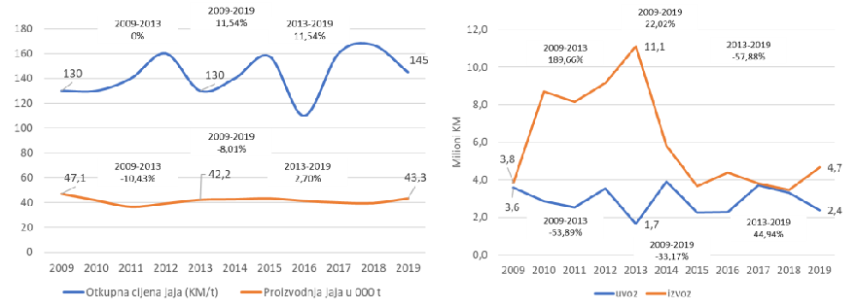
Figure 1. This is a figure. Schemes follow the same formatting. Assure proper format of the figures and schemes, pictures.

Table 1. This is a table. Tables should be placed in the main text near to the first time they are cited.
Title 1 | Title 2 | Title 3 | Title 4
entry 1 * | data | data | data
 | data | data | data
 | data | data | data
entry 2 | data | data | data
 | data | data | data
entry 3 | data | data | data
 | data | data | data
 | data | data | data
 | data | data | data
entry 4 | data | data | data
 | data | data | data
* Tables may have a footer.
Displayed equations are centered and set on a separate line.
x + y = z
Conclusions
This section should be conscise, not repeating the text from above and provide some recommendations for further studies, as well as present limitations of the study.
References
References in the text should be cited as follows:
Mujčinović, A., Nikolić, A., Tuna, E., Stamenkovska, I. J., Radović, V., Flynn, P., & McCauley, V. (2021). Is it possible to tackle youth needs with agricultural and rural development policies? Sustainability (Switzerland), 13(15). https://doi.org/10.3390/su13158410
Puigdueta, I., Aguilera, E., Cruz, J. L., Iglesias, A., & Sanz-Cobena, A. (2021). Urban agriculture may change food consumption towards low carbon diets. Global Food Security, 28. https://doi.org/10.1016/j.gfs.2021.100507
White, J. (2011). Book Review: The SAGE Handbook of Qualitative Research. Evaluation Journal of Australasia, 11(2), 52–53. https://doi.org/10.1177/1035719x1101100208

In the list of references, paper should be arranged in alphabetical order of the first author in the Reference list and listed individually at the end of the manuscript. We recommend preparing the references with a bibliography software package, such as EndNote, ReferenceManager or Zotero to avoid typing mistakes and duplicated references. Include the digital object identifier (DOI) for all references where available.
APA 6 citation style recommended.

Abstract on Bosnian/Croatian/Serbian

